Ideation Phase
Define the Problem Statements

Date | 28 NOVEMBER 2025
Team ID
Project Name | BOOK STORE
Maximum Marks | 2 Marks

Customer Problem Statement Template:
To define the core problems customer face while searching and purchasing books online, and use those insights to guide the Online Book Store solution.

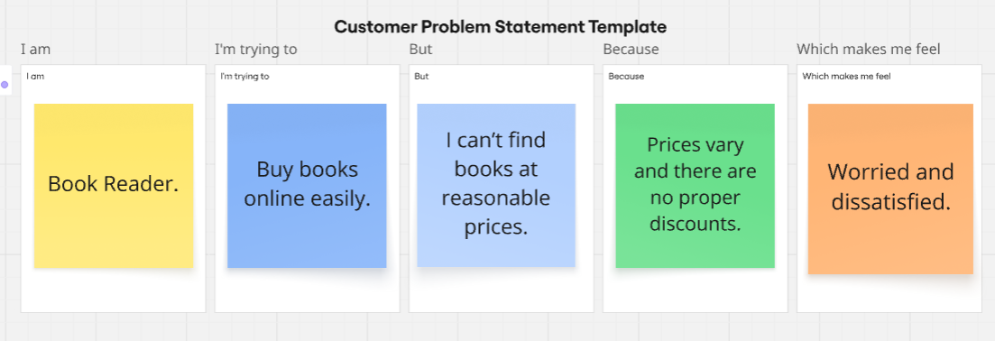
Reference: https://miro.com/templates/customer-problem-statement/

Problem Statement (PS) | I am (Customer) | I’m trying to | But | Because | Which makes me feel
PS-1 | Working professional | Purchase books and get them delivered quickly. | Shipping time is too slow. | Limited delivery partners and delayed dispatch. | Helpless and frustrated.
PS-2 | Student. | Find specific  academic  books. | Many books are out-of-stock. | Stores do not update stock availability. | Stressed and anxious during exams.

